FINAL TEST EVALUATION
============================================================
✅ Loaded best model from best_pos_tagger_model_FOLDER.pt for final evaluation.

Evaluating: 100%
1/1 [00:09<00:00, 9.87s/it, loss=0.4934, acc=0.8348]
Test Loss: 0.4934
Test Accuracy: 0.8348 (83.48%)

🎉 TRAINING COMPLETE ON GAUDI HPU!
Best Val Acc: 0.8328
Final Test Acc: 0.8348
Final Test Accuracy Classification: 📈 Decent. Room for improvement.

📚 Vocabulary Summary:
---------------------------------------------
Words: 6,485
POS tags: 18
Sample words: ['Gero', ',', 'lortutako', 'masa', 'batean', 'jarri', '.', 'Bestalde', '"', 'herri', '...']
POS tags: ['ADV', 'PUNCT', 'VERB', 'NOUN', 'NUM', 'CCONJ', 'ADJ', 'AUX', 'PROPN', 'DET', 'PRON', 'PART', 'SYM', 'INTJ', 'X', 'SCONJ', 'ADP']
---------------------------------------------

📈 Metrics plot saved to training_metrics.png

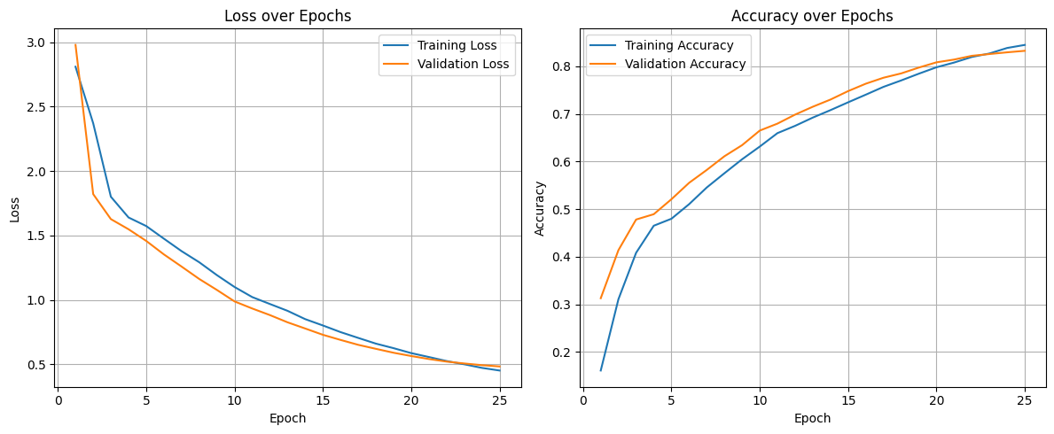
📊 POS Tagging Results (Random Sample from Test Set):
---------------------------------------------

--- Sample Sentence 1 ---
Word | Predicted Tag | Actual Tag | Correct?
-----------------------------------------------------------------
Kubako | PROPN | PROPN | ✅
eta | CCONJ | CCONJ | ✅
<unk> | NOUN | NOUN | ✅
<unk> | NOUN | VERB | ❌
dauden | VERB | AUX | ❌
atzerriko | NOUN | NOUN | ✅
<unk> | NOUN | NOUN | ✅
aurrean | ADP | ADP | ✅
egindako | VERB | VERB | ✅
lehen | ADJ | ADJ | ✅
<unk> | NOUN | NOUN | ✅
, | PUNCT | PUNCT | ✅
esan | VERB | VERB | ✅
zuen | AUX | AUX | ✅
prentsa | NOUN | NOUN | ✅
<unk> | NOUN | NOUN | ✅
batzuek | DET | DET | ✅
<unk> | NOUN | ADJ | ❌
eta | CCONJ | CCONJ | ✅
<unk> | PROPN | PROPN | ✅
herriaren | NOUN | NOUN | ✅
kanpo | ADP | NOUN | ❌
<unk> | NOUN | NOUN | ✅
<unk> | NOUN | ADJ | ❌
<unk> | NOUN | NOUN | ✅
jo | VERB | VERB | ✅
zutela | AUX | AUX | ✅
. | PUNCT | PUNCT | ✅

--- Sample Sentence 2 ---
Word | Predicted Tag | Actual Tag | Correct?
-----------------------------------------------------------------
<unk> | NOUN | VERB | ❌
egin | VERB | VERB | ✅
behar | NOUN | NOUN | ✅
dira | VERB | VERB | ✅
: | PUNCT | PUNCT | ✅

--- Sample Sentence 3 ---
Word | Predicted Tag | Actual Tag | Correct?
-----------------------------------------------------------------
<unk> | NOUN | PROPN | ❌
sarritan | ADV | ADV | ✅
jokatu | VERB | VERB | ✅
izan | AUX | AUX | ✅
dira | AUX | AUX | ✅
<unk> | NOUN | NOUN | ✅
probak | NOUN | NOUN | ✅
, | PUNCT | PUNCT | ✅
eta | CCONJ | CCONJ | ✅
esperientzia | NOUN | NOUN | ✅
dute | VERB | VERB | ✅
. | PUNCT | PUNCT | ✅

--- Sample Sentence 4 ---
Word | Predicted Tag | Actual Tag | Correct?
-----------------------------------------------------------------
Luis | PROPN | PROPN | ✅
<unk> | NOUN | PROPN | ❌
fiskalak | ADJ | NOUN | ❌
, | PUNCT | PUNCT | ✅
hau | DET | DET | ✅
ikusita | VERB | VERB | ✅
, | PUNCT | PUNCT | ✅
Alegriak | NOUN | PROPN | ❌
<unk> | NOUN | VERB | ❌
adierazpena | NOUN | NOUN | ✅
ere | CCONJ | CCONJ | ✅
<unk> | NOUN | NOUN | ✅
zela | AUX | AUX | ✅
azaltzen | VERB | VERB | ✅
saiatu | VERB | VERB | ✅
zen | AUX | AUX | ✅
, | PUNCT | PUNCT | ✅
baina | CCONJ | CCONJ | ✅
fiskalak | ADJ | NOUN | ❌
1997an | NUM | NUM | ✅
aurkeztu | VERB | VERB | ✅
<unk> | AUX | NOUN | ❌
<unk> | NOUN | ADV | ❌
esaten | VERB | VERB | ✅
da | AUX | AUX | ✅
adierazpenetan | NOUN | NOUN | ✅
ez | PART | PART | ✅
dela | AUX | AUX | ✅
delitu | NOUN | NOUN | ✅
<unk> | ADJ | NOUN | ❌
ikusten | VERB | VERB | ✅
. | PUNCT | PUNCT | ✅

--- Sample Sentence 5 ---
Word | Predicted Tag | Actual Tag | Correct?
-----------------------------------------------------------------
OSASUNAK | PROPN | PROPN | ✅
ezin | NOUN | NOUN | ✅
izan | VERB | VERB | ✅
zuen | AUX | AUX | ✅
<unk> | NOUN | NOUN | ✅
lortu | VERB | VERB | ✅
<unk> | NOUN | PROPN | ❌
, | PUNCT | PUNCT | ✅
<unk> | PROPN | NOUN | ❌
<unk> | NOUN | NOUN | ✅
<unk> | NOUN | NOUN | ✅
gora | ADP | ADP | ✅
jarritako | VERB | VERB | ✅
partiduan | NOUN | NOUN | ✅
. | PUNCT | PUNCT | ✅
---------------------------------------------

🧠 Analysis of Sample POS Tagging Results:
---------------------------------------------
Total words analyzed in samples: 92
Correct predictions in samples: 75
Incorrect predictions in samples: 17
Sample Accuracy: 81.52%

--- Performance on Unknown (<unk>) Words ---
Total <unk> words in samples: 24
Correct <unk> predictions: 12
Incorrect <unk> predictions: 12
Accuracy on <unk> words: 50.00%
Observation: The model shows some ability to guess tags for unknown words, which is good.

--- Common Tagging Errors (Predicted -> Actual) ---
- Predicted 'NOUN' but was actually 'PROPN': 4 times
- Predicted 'NOUN' but was actually 'VERB': 3 times
- Predicted 'ADJ' but was actually 'NOUN': 3 times
- Predicted 'NOUN' but was actually 'ADJ': 2 times
- Predicted 'VERB' but was actually 'AUX': 1 times
Observation: Specific tag confusions indicate areas for model refinement or more diverse training data for those tags.

--- Overall Sample Quality Assessment ---
Conclusion: The sample predictions are generally good, with some minor errors. The model performs solidly.
---------------------------------------------

1
Python 3 (ipykernel) | Idle
Mode: Command
Ln 1, Col 1
Tagger_Using_Folder.ipynb
1

